**Details of vessel**

|  |  |
| --- | --- |
| Name | MSC SILVER II |
| IMO | 9225249 |
| Call Sign | 5LGA8 |

**Particulars of Agent / Floating Armoury**

|  |  |
| --- | --- |
| Name of Company | United Guards Services LTD |
| Date | 2023/10/03 |
| Embark / Disembark | Embarked |

**Details of Weapons & Ammo**

|  |  |  |  |  |  |
| --- | --- | --- | --- | --- | --- |
| **Weapons** | | | | | |
| Make | Model | Serial Number | UG Box / Peli Case Number | Number of Magazines | Defects |
| Zastava | M2010 | 1529 | **UGS 035A** | 6 |  |
| Zastava | M2010 | 1530 | **UGS 035A** |  |  |
| Zastava | M2010 | 1531 | **UGS 035A** |  |  |
|  |  |  |  |  |  |
| **Ammunition UGS115B** | | | | | |
| Caliber | | Number | | Defects | |
| 7.62x51 | | 591 | |  | |

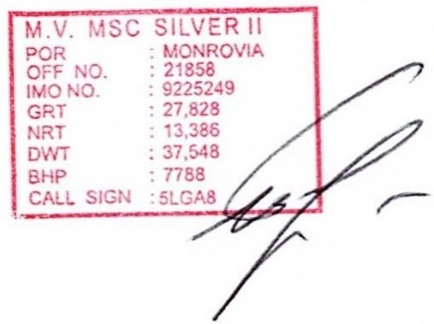**Details of Other Specified Kit**

|  |  |  |  |
| --- | --- | --- | --- |
| Item | UG Box / Peli case number | Quantity | Defects |
|  | UGS 035B |  |  |
| Vests |  | 3 |  |
| Sarkar Ceramic plates |  | 6 |  |
| Boafeng radios and chargers |  | 3 |  |
| Bushnell Binoculars |  | 1 |  |
| Radios headphones |  | 3 |  |
| Ammo pouches |  | 3 |  |
| Cleaning kit |  | 3 |  |
| Action Camera |  | 1 |  |
| Padlocks |  | 2 |  |
| Helmets |  | 3 |  |
| Gun oil |  | 2 |  |
| MTM boxes |  | 9 |  |
| Reason for usage: | Embarkation/ Disembarkation | | |
| Sat Phone Number: |  | | Remarks |
|  |
| Credit at: |  | |  |

TL Name: Master:

Signed: Signed:

On Behalf Of: On Behalf Of:MSC SILVER II