**Details of vessel**

|  |  |
| --- | --- |
| Name | MSC SILVER II |
| IMO | 9225249 |
| Call Sign | 5LGA8 |

**Particulars of Agent / Floating Armoury**

|  |  |
| --- | --- |
| Name of Company | M/V GOLDEN PALM |
| Date | 2023/10/03 |
| Embark / Disembark | Embarked |

**Details of Weapons & Ammo**

|  |  |  |  |  |  |
| --- | --- | --- | --- | --- | --- |
| **Weapons** | | | | | |
| Make | Model | Serial Number | UG Box / Peli Case Number | Number of Magazines | Defects |
| ZASTAVA M2010 | Semi automatic | 1529 | UGS035A | 6 |  |
| ZASTAVA  M2010 | Semi automatic | 1530 |  |  |  |
| ZASTAVA  M2010 | Semi automatic | 1531 |  |  |  |
| Slingsx2 |  |  |  |  |  |
|  |  |  |  |  |  |
| **Ammunition UGS035B** | | | | | |
| Caliber | | Number | | Defects | |
| 7.62x51 | | 591 | |  | |

**Details of Other Specified Kit**

|  |  |  |  |
| --- | --- | --- | --- |
| Item | UG Box / Peli case number | Quantity | Defects |
|  | UGS035C |  |  |
| Body armour case |  | 1 |  |
| Plate carriers |  | 3 |  |
| Ceramic plates |  | 6 |  |
| Helmets |  | 3 |  |
| Radios |  | 3 |  |
| Chargers for radios |  | 3 |  |
| Cleaning kit |  | 1 |  |
| Binocular |  | 1 |  |
| Magazine pouches |  | 0 |  |
|  |  |  |  |
| Reason for usage: | Embarkation/ Disembarkation | | |
| Sat Phone Number: | NIL | | Remarks |
|  |
| Credit at: |  | |  |

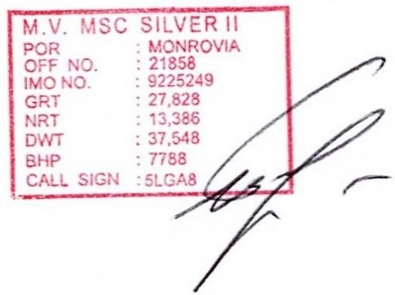

TL Name:Francois Viljoen Master: Capt. TARNAVSKYI IGOR

Signed: Signed:

On Behalf Of:United Guards On Behalf Of:MSC SILVER II