**ARMS AND AMMUNITIONS LIST**

|  |  |  |
| --- | --- | --- |
| 1. Name of Ship   **m.v MARSA VICTORY** | 1. Port of Arrival   **ADEN** | 1. Date of Arrival   **22.09.2024** |
| 1. Nationality of Ship   **ST. KITTS & NEVIS** | 1. Port Arrived From   **DJIBOUTI** | 1. Next Port   **DJIBOUTI** |

NO HAVE any Arms or Ammunitions on board.

|  |  |  |
| --- | --- | --- |
| **Serial no of weapons** | **Kind of weapons** | **Location/owner** |
|  |  |  |
| **Ammo :** | | |
|  |  |  |
| **total** |  |  |
| nil | | |

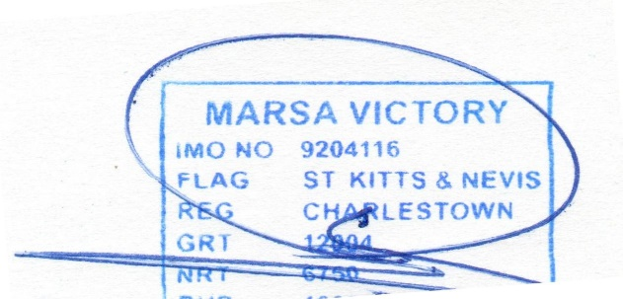MASTER, MV MARSA VICTORY

Master signature & vessel stamp