**20’ Feet Cell Guide Whether In (Hatch Or On Deck)**

**Vessel Name:** _________________MARSA IVY _____________________

Is there bays fitted with **20’ feet** cell guides (Yes / No): _____**NO**________

If there is **20’ feet** containers cell guides,   
which bays are with **20’ feet** containers cell guides: ____________**N/A**______________

__________________________

__________________________

__________________________

__________________________

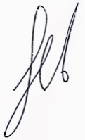



C/O AHAIEV AIDYN

**____________________________________ ____________________________**

**Name & signature of Chief Officer / Agent Chief Officer / Agent's company**

**Authorized Representative stamp, and date/time submitted**